**EE201C Homework1**

Student Name: Ziyin You

Student UID: 404412651

*[1] Given three wires, each modeled by at least 2 filaments, find the 3x3 matrix for (frequency-independent) inductance between the 3 wires, along with the capacitance and resistance. We assume that the ground plane has infinite size and is 10 um away for the purpose of capacitance calculation.*

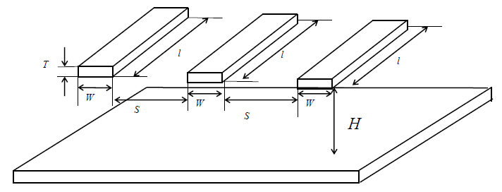

*Step 1.1*

**Solution:**

There are 3 wires into 6 filaments. For each filament, the self-inductance is:

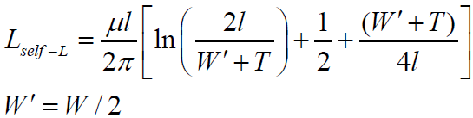

And for each pair of filament, the mutual inductance is:

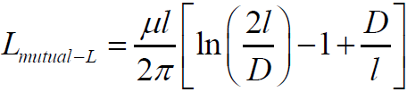

With the equations above, the Matlab code can be coded like below:

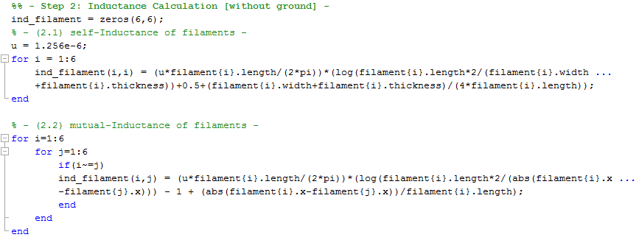

The results are shown in the table below. Notice that when i = j (11, 22, 33, etc.), it is self-inductance. And when i!= j, it is mutual-inductance.

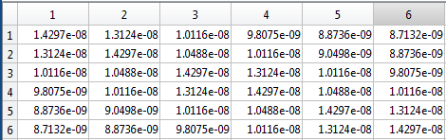

*Step 1.2*

**Solution:**

Known that the equation to calculate the wire inductance can be expressed as below (where k=m means that Lp is the self Lp for one conductor):

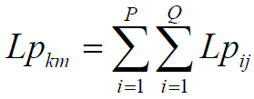

So the Matlab code can be coded like below:

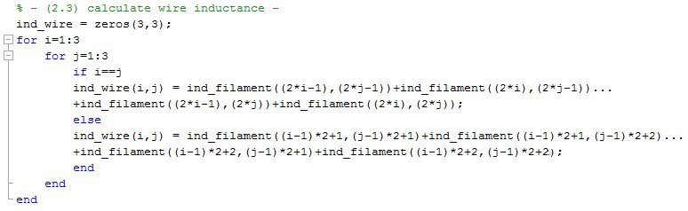

Then the result is shown below:

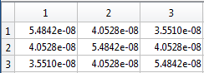

The self-inductance of 1, 2, and 3 are all **54.842nH**. The mutual-inductance between 1, 3 is **35.51nH**. The mutual-inductance between 1,2 is **40.528nH**.The mutual-inductance between 2, 3 is also **40.528nH**.

*Step 1.3*

**Solution:**

The graphic of the capacitors are shown below:

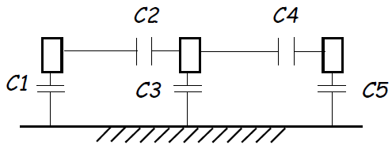

For a single wire above ground, the ground capacitance per unit length is as follows:

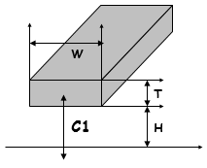



For three wires above ground, the total capacitance of middle wire per unit length is:



This can be split into ground and coupling, that is Sakurai-Tamaru, which is C3+C2+C4 shown below:

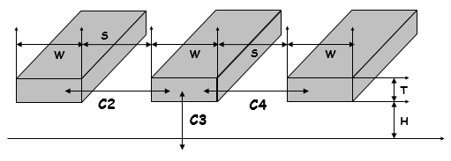



Since C1 and C5 equals to average of single wire over ground and there parallel wires over ground, C1 = C5 = [C3 + (C3 + 2*C2)]/2.

With all the equations given above, the Matlab code can be like below:

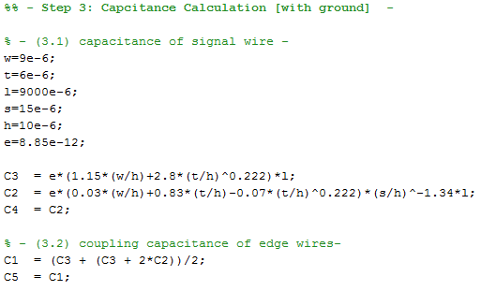

So C1 = C5 = **3.0294e-13 F**, C2 = C4 = **2.1396e-14 F**, and C3 = **2.8155e-13 F**.

*Step 1.4*

**Solution:**

We know that Copper electrical resistivity 0.0175 Ωmm2/m (room temperature), also the equation:



So the Matlab code can be easily got as below:

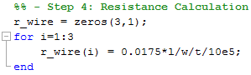

And the value is calculated by Matlab to be **2.9176**.

*[2] Build the RC and RCL circuit models in SPICE netlist for the above wires. (suggest to use Matlab script to generate matrix and thus SPICE netlist)*

**Solution:**

The RC circuit model is built in LTSpice. The netlist .sp file is generated by using Matlab as shown in the left figure below. The generated circuit is shown in the right figure below:

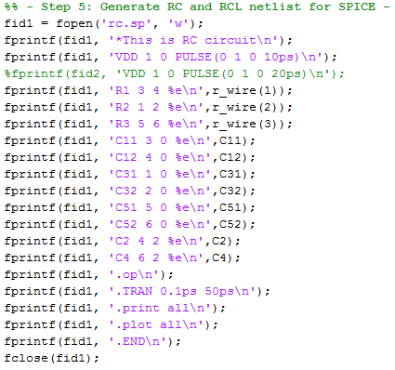 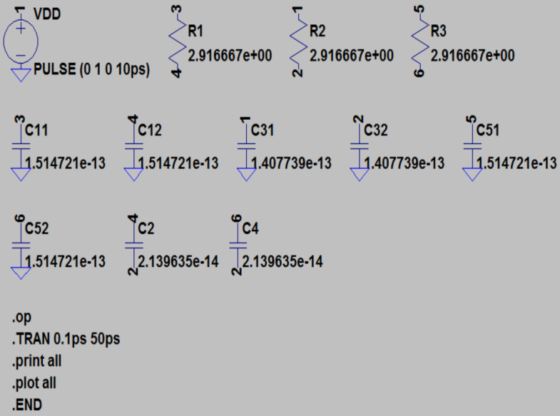

And the RLC circuit model is generated by using Matlab as shown in the left figure below. The circuit is shown in the right figure below:

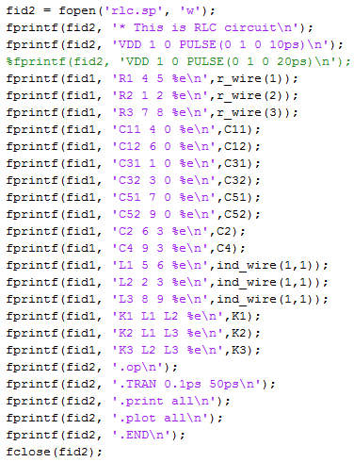 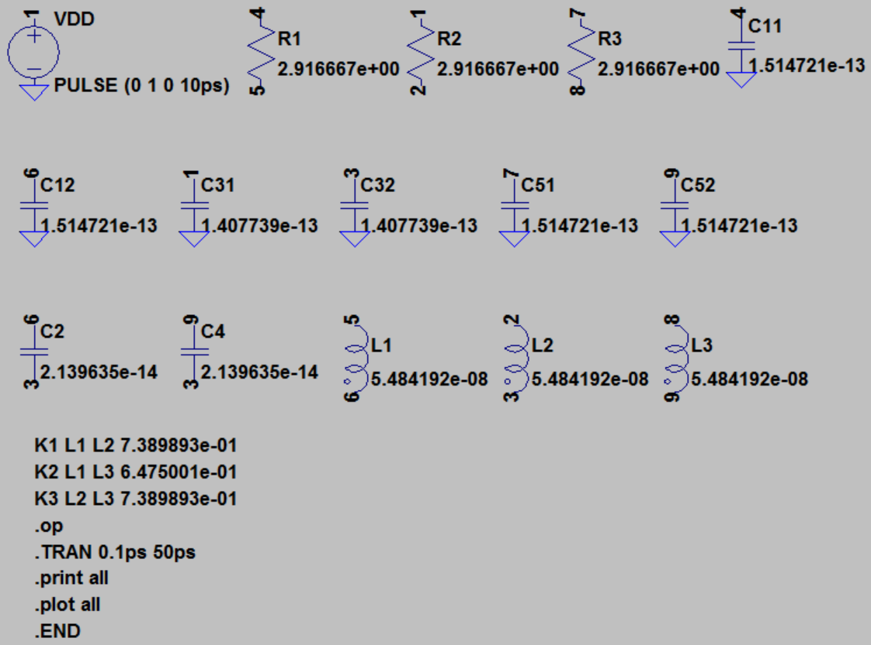

*[3] Assume a step function applied at end-end, compare the four waveforms at the far-end for the central wire using SPICE transient analysis for (a) RC and RLC models and (b) rising time is 20ns, or try to use longer rising time.*

**Solution:**

As shown in [2] above, the rising time is set to be 10ps. Then the waveforms at the far-end for the central wire versus the waveform of the step input can be plotted as below:

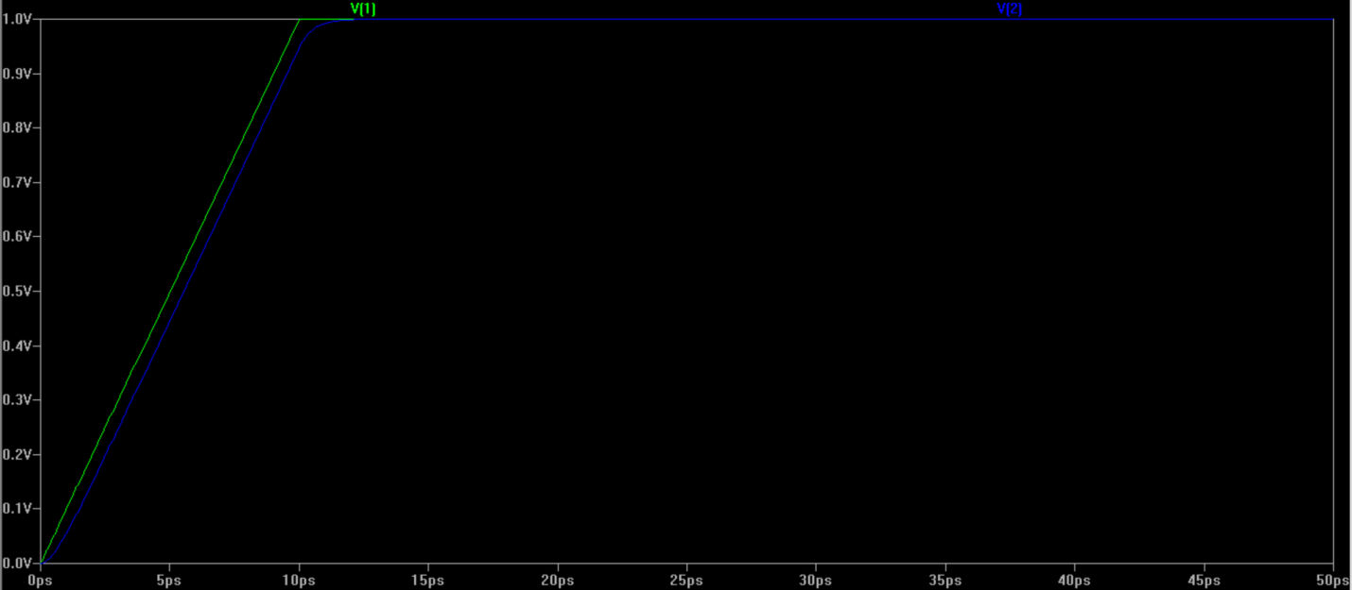

(RC model with 10ps input rising time)

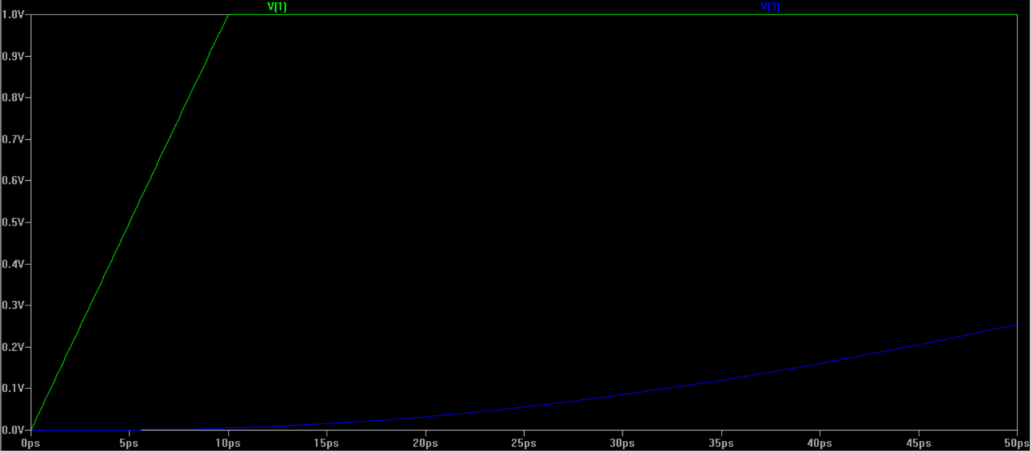

(RLC model with 10ps input rising time)

Then, the rising time is changed to be 20ps. The waveforms at the far-end for the central wire versus the waveform of the step input can be plotted as below:

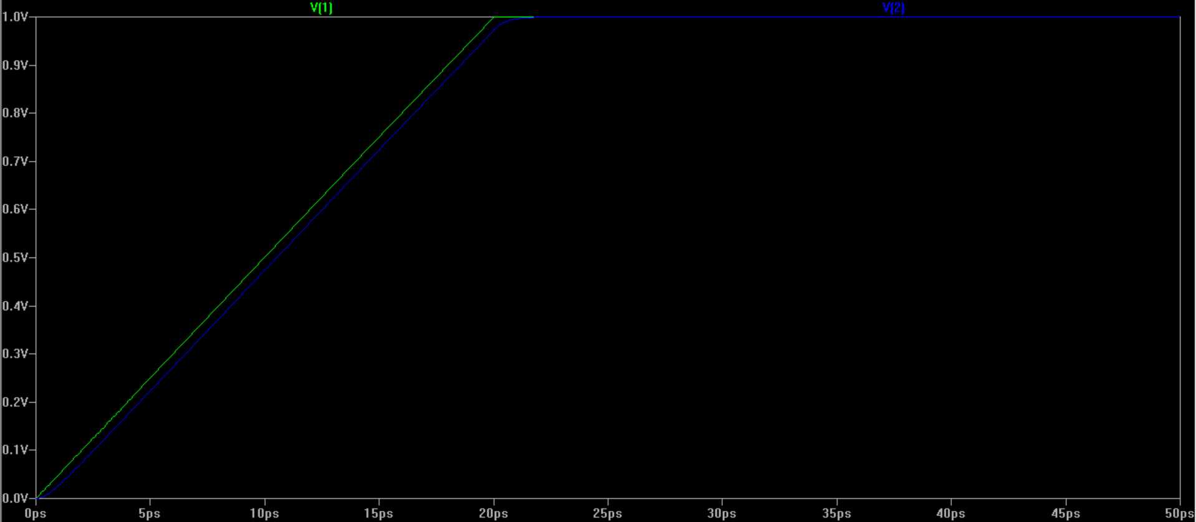

(RC model with 20ps input rising time)

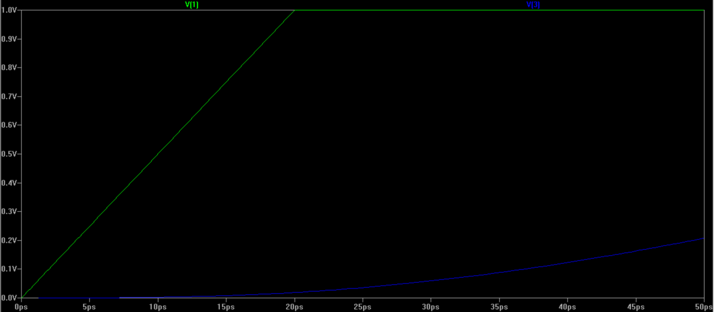

(RLC model with 20ps input rising time)